


THE YENEPOYA INSTITUTE OF ARTS SCIENCE

COMMERCE AND MANAGEMENT

Project – Low Level Design

ON

Design and Development of Identity Security
Framework for Finance

Student Name:Amritha Jayakumar Guided by:Thanziha REG NO:23BSCED003

Table of Contents

1. Introduction—------------------------------------------------------------------- 3
1.1 Purpose and Scope—------------------------------------------ 3
1.2 Project Executive Summary—------------------------------- 3
1.3 Constraints—---------------------------------------------------- 3
1.4 Document Organization—------------------------------------ 3
2. System Overview—--------------------------------------------------------------- 4
3. Module Design—------------------------------------------------------------------ 4
3.1 User Management Module—------------------------------------- 4
3.2 Verification Module—----------------------------------------------- 5
3.3 Access Control Module—------------------------------------------- 5
3.4 Session Management Module—---------------------------------- 5
3.5 Logging and Monitoring Module—------------------------------- 6
4. Data Flow Design—------------------------------------------------------------------ 6
5. Database Design—------------------------------------------------------------------- 7
5.1 User Table—----------------------------------------------------------- 7
5.2 Verification Table—-------------------------------------------------- 8
5.3 Log Table—------------------------------------------------------------- 8
6. User Interface Design—------------------------------------------------------------ 9
7. Security Implementation—-------------------------------------------------------- 10
8. Testing and Validation—------------------------------------------------------------- 11
9. Glossary—------------------------------------------------------------------------------ 12
10. Front-end—--------------------------------------------------------------------------- 13
11. Back-end—---------------------------------------------------------------------------- 14
12.References—--------------------------------------------------------------------------- 15

1. Introduction

1.1 Purpose and Scope
This Low-Level Design (LLD) document provides a detailed component-level specification of the NexaBank — Identity Security Framework. It dictates the internal logic, database structures, security protocols, and data flow required to implement the banking system. The scope includes module definitions, schema descriptions, and interface layouts directly reflecting the Python/Flask codebase.

1.2 Project Executive Summary
NexaBank is a web-based banking application built using Python, Flask, and SQLite. It provides secure account management, transaction processing (NEFT, IMPS, UPI), and strict identity verification using OTPs, account lockouts, and cryptographic password hashing. The application follows the MVC pattern: Flask route handlers as controllers, SQLAlchemy models as the data layer, and Jinja2 templates as the view layer.

1.3 Constraints

- Technology Stack: Must use Python, Flask, Flask-Login, and SQLite.
- Security: Passwords must be hashed via bcrypt/scrypt; all forms must embed CSRF tokens.
- Performance: Must respond rapidly in a local or constrained academic hosting environment.
- Storage: Caching of sensitive financial data is strictly prohibited via HTTP response headers.

1.4 Document Organization

This document is organized into module designs, database schemas (Data Dictionary), data flows, UI layouts, and dedicated front-end/back-end specifications to guide developers through the implementation phase. Each section maps directly to an implementation concern within the NexaBank codebase.

2. System Overview

The NexaBank architecture is a monolithic web application leveraging the Flask framework. The backend manages routing, authentication, business logic, and database transactions using SQLAlchemy. The frontend consists of Jinja2 HTML templates styled with a unified CSS design system.

Layer | Technology | Primary Responsibility
Presentation | HTML5, CSS3, Vanilla JS, Jinja2 | UI rendering, client-side validation, dynamic interactions
Routing / Controller | Flask (Python) | URL dispatch, request handling, authentication guards
Business Logic | Python — Flask route handlers | Transfer processing, OTP verification, FD interest, lockout
Data Access | SQLAlchemy ORM | CRUD operations, relationship traversal, paginated queries
Database | SQLite (dev) / PostgreSQL (prod) | Persistent storage for users, transactions, and audit logs
Security Middleware | Flask-Login, Flask-WTF, Werkzeug | Sessions, CSRF tokens, password hashing

3. Module Design

3.1 User Management Module

Functionality: Handles user registration, profile viewing, and password updates.
Internal Logic:
- Generates a unique 12-digit account number upon signup using random.choices.
- Hashes passwords using bcrypt/scrypt before database insertion via set_password() method on the User model.
- Prevents duplicate email registrations by querying existing User records before insertion.
- Exposes computed properties: masked_account, first_name, ifsc_code, and account_type.
Associated Files: app.py (routes: /signup, /profile, /change-password), models.py (User class), forms.py (SignupForm, ChangePasswordForm).

3.2 Verification Module

Functionality: Implements Two-Factor Authentication (2FA) via Email OTP for logins and fund transfers.
Internal Logic:
- Generates a 6-digit random numeric OTP using Python's secrets module.
- Stores OTP temporarily in the server-side Flask session alongside a UNIX timestamp (session['login_otp_time']).
- Dispatches OTP via Flask-Mail to the user's registered email address.
- Validates user-submitted OTP against the session value and expires it after 120 seconds.
- A JavaScript countdown timer on otp_verify.html displays remaining time and auto-redirects on expiry.
Associated Files: app.py (routes: /verify_login, /verify_transfer, function: send_otp_email()).

3.3 Access Control Module

Functionality: Restricts access to sensitive routes based on authentication and authorization levels.
Internal Logic:
- Uses the @login_required decorator from Flask-Login to protect all private endpoints.
- Uses a custom @admin_required wrapper to restrict access to the /admin dashboard route.
- Checks User.is_locked status at login time to prevent brute-force entries.
- Admin panel link in the sidebar is conditionally rendered only for role == 'admin' users.
Associated Files: app.py (login_manager setup, admin_required wrapper function).

3.4 Session Management Module

Functionality: Maintains user state securely between stateless HTTP requests.
Internal Logic:

- Utilises Flask's cryptographically signed cookies (using SECRET_KEY) for session storage.
- Configured with SESSION_COOKIE_HTTPONLY = True, SESSION_COOKIE_SECURE = True, SESSION_COOKIE_SAMESITE = 'Lax'.
- Implements absolute timeout logic in @app.before_request — if elapsed time since session start exceeds 15 minutes, session is cleared and user is redirected to login.
- logout_user() from Flask-Login explicitly invalidates the session on user logout.
Associated Files: app.py (Configuration block, check_timeout() before_request handler).

3.5 Logging and Monitoring Module

Functionality: Audits security events, primarily login successes and failures.
Internal Logic:
- Captures client IP addresses via request.headers.get('X-Forwarded-For', request.remote_addr).
- Records each login event's success status and specific reason (e.g., wrong_password, account_locked, login_success, otp_expired).
- LoginAttempt records are persisted to the login_attempts table and displayed in the security_log.html page (last 20 events).
Associated Files: models.py (LoginAttempt model), app.py (log_attempt() utility function).

4. Data Flow Design

The following describes the end-to-end data flow for a fund transfer — the most complex transactional operation in the system:

Step | Actor / Component | Action
1 | Browser (Client) | User completes transfer form (beneficiary, account, IFSC, amount, type). Submits via HTTP POST with session cookie and CSRF token.
2 | Flask-WTF (CSRF Layer) | CSRF token is validated. Request is rejected with HTTP 400/403 if token is absent or invalid.
3 | @login_required Decorator | Flask-Login verifies an active authenticated session. Redirects to /login if session is expired or absent.
4 | Route Handler — /transfer | Business logic checks: (a) amount > 0, (b) amount <= current_user.balance, (c) amount within per-type limits (NEFT ≤ 10L, IMPS ≤ 5L, UPI ≤ 1L).
5 | Verification Module | If checks pass, OTP is generated, stored in session with timestamp, and dispatched via Flask-Mail. User is redirected to /verify_transfer.
6 | OTP Verification | User submits 6-digit OTP. System validates against session value and timestamp (< 120s). On failure — retry. On expiry — redirect with error.
7 | SQLAlchemy ORM | On successful OTP: (a) sender balance decremented, (b) Transaction record (debit) committed, (c) Notification record created — all in a single db.session.commit().
8 | Response | User redirected to /dashboard or /transactions with a flash success message confirming the transfer reference.

5. Database Design
As the framework utilises SQLite via SQLAlchemy, tables map directly to Python classes defined in models.py. The following tables constitute the NexaBank schema:

5.1 User Table
Table Name: users

Field Name | Data Type | Constraints / Attributes
id | Integer | Primary Key, Auto-increment
full_name | String(120) | Not Null
email | String(150) | Unique, Not Null
phone | String(15) | Not Null
account_no | String(20) | Unique, Not Null
password_hash | String(256) | Not Null — bcrypt/scrypt hash; plaintext never retained
balance | Float | Default 0.0
role | String(20) | Default 'customer'; also accepts 'admin'
failed_attempts | Integer | Default 0; incremented on wrong password
is_locked | Boolean | Default False; set True after 5 failures
locked_until | DateTime | Nullable; set to now + 15 min on lockout
last_login | DateTime | Nullable; updated on successful OTP verification
created_at | DateTime | Default UTC Now

5.2 Verification / Transaction Table
In NexaBank, temporary verification codes (OTPs) are intentionally not persisted to a dedicated database table. Instead, they are stored ephemerally within Flask's server-side signed session dictionary alongside a UNIX creation timestamp. This design prevents database bloating, eliminates the risk of OTP leakage through database breaches, and ensures codes are automatically discarded when the session expires. The session entry is explicitly cleared once the OTP is consumed or has expired.
For the persistent verification of all financial events, the transactions table serves as the authoritative ledger. Each record carries a unique auto-incremented id as its primary key, and a user_id foreign key that links it back to the users table. The txn_type field classifies the nature of the transaction, with accepted values being neft, imps, upi, atm, and fd. The amount field stores the monetary value as a Float and must always be greater than zero. The direction field is constrained to either credit or debit, unambiguously indicating the movement of funds. A balance_after Float captures the account balance immediately after the transaction is committed, providing a self-contained running ledger. Each transaction is assigned a system-generated reference string which acts as the human-readable transaction identifier shown to the user. The description field holds a plain-language summary. Finally, created_at records the UTC timestamp of record creation and defaults to the current time at the moment of database insertion.

5.3 Log Table

Table Name: login_attempts

Field Name | Data Type | Constraints / Attributes
id | Integer | Primary Key, Auto-increment
user_id | Integer | Foreign Key → users.id, Nullable (for unknown email attempts)
email | String(150) | Not Null — email attempted, even for non-existent accounts
ip_address | String(50) | Not Null — captured from X-Forwarded-For or remote_addr
success | Boolean | Not Null — True if login fully completed (OTP passed)
reason | String(50) | Default '' — e.g. wrong_password, account_locked, otp_expired, login_success
created_at | DateTime | Default UTC Now

The login_attempts table constitutes the security audit trail for the entire application. Every login event — whether successful or failed — is recorded as a distinct row in this table. Each record carries a unique auto-incremented id. The user_id foreign key links the attempt to a registered user where the email is recognisable; it is left Nullable to accommodate attempts made against email addresses that do not exist in the system. The email field itself is always captured, ensuring even probing attempts against unknown accounts are logged. The ip_address field stores the originating client IP, resolved by checking the X-Forwarded-For header first (for reverse-proxy environments) and falling back to request.remote_addr. The success Boolean is set to True only when the full two-step authentication — password verification followed by correct OTP submission — is completed. The reason field provides a machine-readable classification of the event outcome, such as wrong_password, account_locked, otp_expired, or login_success, enabling forensic analysis and automated alerting. The created_at timestamp defaults to the current UTC time at insertion.

6. User Interface Design

The NexaBank portal provides 17 Jinja2-rendered HTML pages following a consistent design system:

Page / Component | Description
Home / Landing (home.html) | Hero section with value propositions, FD rate table, feature grid, security section, and CTA banner.
Login (login.html) | Split-panel layout: left branding/security indicators, right credential form with password visibility toggle and Remember Me checkbox.
OTP Verify (otp_verify.html) | Minimal card with 6-digit OTP input and live JavaScript countdown timer. Auto-redirects on expiry.
Dashboard (dashboard.html) | Balance card, account details, quick actions grid, active FDs, spending breakdown bar chart, and recent transactions list.
Transactions (transactions.html) | Paginated statement table with credit/debit filter. Reference, description, type badge, debit/credit columns, and running balance.
Fund Transfer (transfer.html) | Tab-based type selector (NEFT / IMPS / UPI), beneficiary details form, live balance-after-transfer preview.
Beneficiaries (beneficiaries.html) | Card grid of saved payees with masked account numbers, one-click Pay button, and delete confirmation dialog.
Fixed Deposits (fixed_deposits.html) | Rate tiles with maturity projections, active FD table with progress bars showing elapsed tenure percentage.
Open FD (open_fd.html) | Principal input, tenure radio selector, live FD returns calculator, and confirmation dialog before submission.
Notifications (notifications.html) | Chronological notification feed with unread indicator dots and type-based styling.
Support (support.html) | Support ticket list table with status badges (Open / Resolved).
Security Log (security_log.html) | Status summary cards (password method, 2FA, account status, failed attempts) and login audit table.
Profile (profile.html) | Personal info, account details, security info, and shortcut buttons to Change Password, Security Log, Notifications.
Admin Dashboard (admin_dashboard.html) | System-wide user table (role/lock status) and global recent transactions. Admin-only access.

Shared Layout Components:
- base.html: Topbar with notification bell, user avatar, and logout button. Flash message stack with dismiss. Background decorative shapes. JS and CSS includes.
- _sidebar.html: Navigation links with active-state highlighting derived from request.endpoint. Unread notification badge. IFSC code display at bottom.
- Typography System: Sora (UI sans-serif), Libre Baskerville (display headings), JetBrains Mono (account numbers, IFSC codes, references).
- Colour System: CSS custom properties — navy, blue, green, amber — ensuring consistent theming across all pages.

7. Security Implementation
- Password Cryptography
  - Passwords are hashed using bcrypt/scrypt via generate_password_hash().
  - Stored in password_hash; plaintext passwords are never saved.
  - Verified using check_password_hash().
- Brute-Force Mitigation
  - Tracks failed_attempts.
  - Locks account after 5 wrong attempts.
  - Lock duration: 15 minutes (locked_until).
- Two-Factor Authentication
  - OTP sent via email after password verification.
  - Stored in session with timestamp.
  - Expires after 120 seconds.
- Cross-Site Scripting (XSS) Prevention
  - Jinja2 auto-escapes all user inputs.
  - Prevents script injection.
- Cross-Site Request Forgery (CSRF) Protection
  - All forms include CSRF tokens (Flask-WTF).
  - Invalid/missing tokens → request rejected.
- SQL Injection Prevention
  - Uses SQLAlchemy ORM only.
  - No raw SQL queries.
  - Inputs are parameterised automatically.
- Security Headers
  - X-XSS-Protection → blocks XSS
  - X-Frame-Options → prevents clickjacking
  - X-Content-Type-Options → prevents MIME sniffing
  - Content-Security-Policy → restricts resource loading
- Session Cookie Security
  - HTTPOnly → blocks JS access
  - Secure → HTTPS only
  - SameSite=Lax → reduces CSRF risk
- Audit Logging
  - Logs all login attempts.
  - Stores IP, email, success status, reason, timestamp.
  - Displays last 20 logs in Security Log page.

8. Testing and Validation

8.1 Input Validation
Input validation is handled primarily by WTForms validators applied in forms.py. Key validators include:
- DataRequired() — ensures mandatory fields are not empty before processing.
- Email() — validates format of the email address field on login and signup forms.
- Length(min=8) — enforces minimum password length of 8 characters.
- NumberRange(min=1) — validates transfer amount and FD principal are positive numbers.
- EqualTo('confirm_password') — ensures password and confirmation fields match on change password form.

8.2 Business Logic Validation
Custom backend validation checks specific business constraints beyond form field validation:
- Transfer amount cannot exceed current balance — validated in the /transfer route before OTP dispatch.
- Per-type transfer limits enforced: NEFT ≤ ₹10,00,000; IMPS ≤ ₹5,00,000; UPI ≤ ₹1,00,000.
- FD principal must be >= ₹1,000 — validated in the /open-fd route handler.
- FD balance check — principal cannot exceed the user's current account balance.
- Duplicate email check on signup — User.query.filter_by(email=...).first() before inserting a new user.

8.3 Session and OTP State Validation
Time-based logic validates OTP freshness before processing any financial action:
- At /verify_login and /verify_transfer: current_time − session['login_otp_time'] > 120 seconds triggers OTP expiry, clears session, and redirects with error.
- Countdown timer on otp_verify.html provides client-side UX indication; server-side check is the authoritative control.
- Session timeout: @app.before_request — if session has a start timestamp and elapsed time exceeds 15 minutes, session is cleared and user is redirected to /login.

9. Glossary

LLD stands for Low-Level Design and refers to the detailed component-level specification that describes the internal logic, data structures, and interface behaviours of the system.

ORM stands for Object-Relational Mapper, a programming technique that translates Python class operations into SQL database queries, allowing developers to interact with the database using Python objects rather than raw SQL statements.

OTP stands for One-Time Password and refers to the six-digit, time-limited numeric code generated during the two-factor authentication process.

CSRF stands for Cross-Site Request Forgery, an attack in which a malicious website tricks an authenticated user's browser into submitting an unintended request to the banking application.

XSS stands for Cross-Site Scripting, an attack in which malicious scripts are injected into web pages viewed by other users, typically to steal session cookies or credentials.

2FA stands for Two-Factor Authentication, a security mechanism that requires two independent forms of verification — in NexaBank's case, a password and an OTP — before granting access.

NEFT stands for National Electronic Funds Transfer, the RBI-regulated batch-based payment system simulated within NexaBank.

IMPS stands for Immediate Payment Service, a real-time twenty-four-by-seven interbank payment system.

UPI stands for Unified Payments Interface, a real-time mobile payment system operated by the National Payments Corporation of India.

DICGC stands for Deposit Insurance and Credit Guarantee Corporation, the entity that insures bank deposits up to five lakh rupees in India.

bcrypt is a password hashing algorithm specifically designed to be computationally expensive, making it resistant to brute-force and dictionary attacks.

SQLite is a lightweight embedded relational database engine used in the development environment, which can be replaced by PostgreSQL in production.

10. Front-end
The NexaBank front-end is built using HTML5, CSS3, and Vanilla JavaScript, with Jinja2 as the template engine for dynamic content rendering. All templates extend a common base.html layout to maintain consistency across pages.
Forms are handled using Flask-WTF with built-in CSRF protection, and validation errors are displayed inline for better user experience. The project structure includes templates in the /templates folder and static files like CSS and JavaScript in the /static folder.
Client-side JavaScript handles interactive features such as balance toggle, FD calculator, fund transfer preview, OTP countdown timer, and transaction filtering, ensuring a responsive and dynamic user interface without using any frameworks.

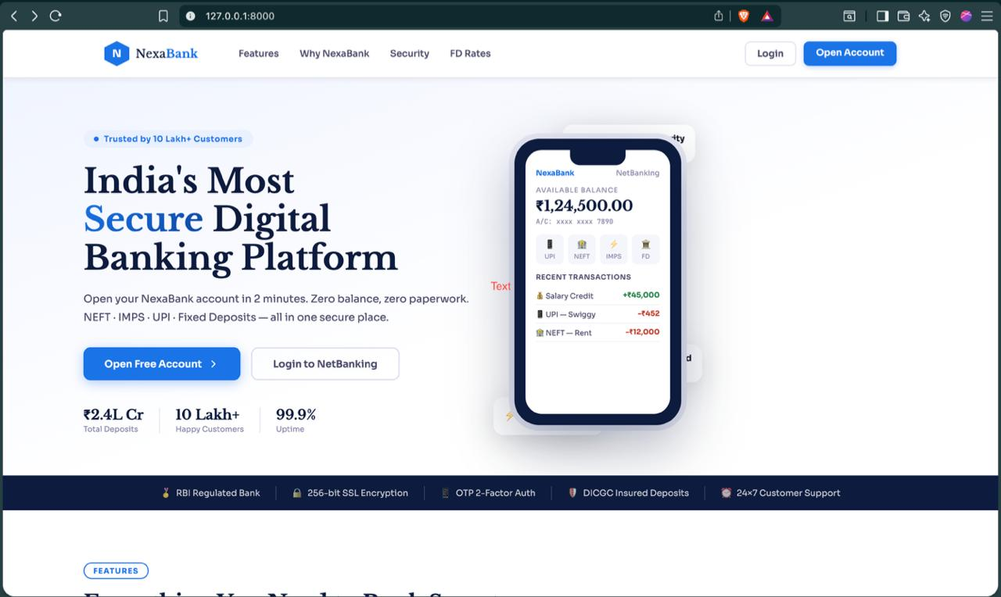

11. Back-end

The NexaBank back-end is built using Python 3 and Flask, with SQLite used in development and PostgreSQL in production via the DATABASE_URL. It uses Flask-SQLAlchemy for database operations and Flask-Login for session management and authentication.
The codebase is mainly organised into app.py (routing and logic), models.py (database models), forms.py (WTForms), and configuration settings within app.py. Key features include OTP-based authentication, secure session handling, and role-based access control.
The system follows clean design practices by keeping routes minimal, handling business logic through models and utilities, and using flash messages for user feedback. Database operations are atomic using db.session.commit(), and transaction records are efficiently managed using pagination.

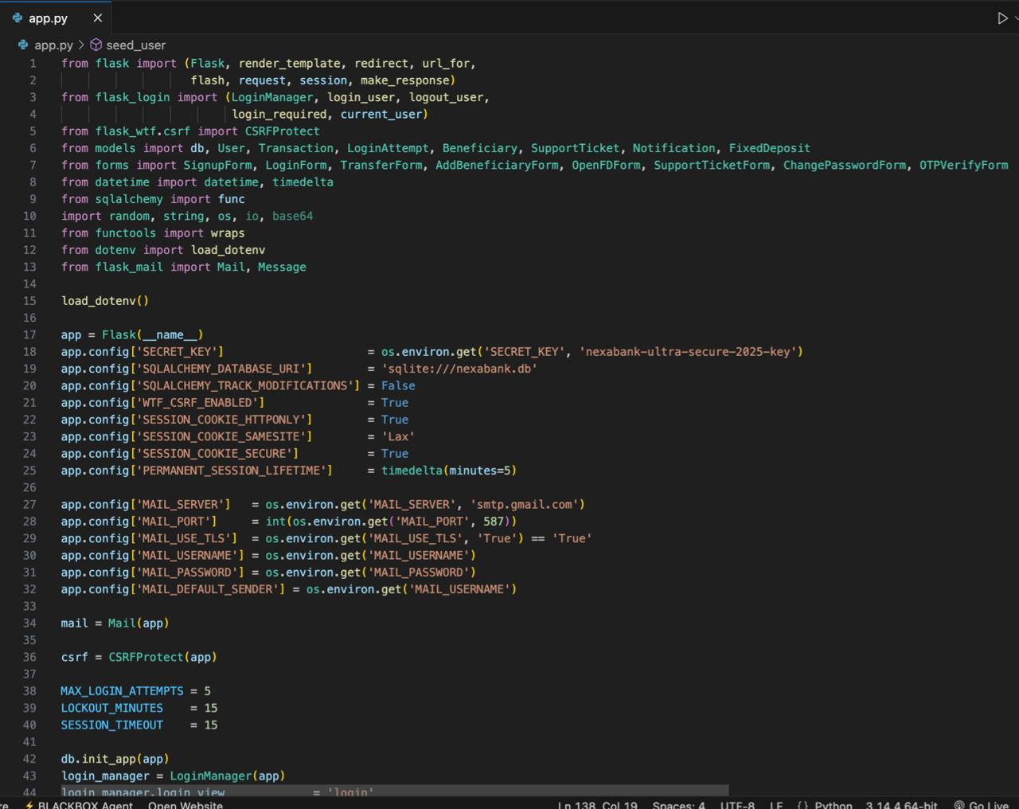

12.References
- Flask Documentation v3.0 — https://flask.palletsprojects.com/en/3.0.x/
- Flask-Login Documentation — https://flask-login.readthedocs.io/en/latest/
- Flask-SQLAlchemy Documentation — https://flask-sqlalchemy.palletsprojects.com/
- Werkzeug Security Utilities — https://werkzeug.palletsprojects.com/en/3.0.x/utils/
- WTForms Documentation — https://wtforms.readthedocs.io/en/3.1.x/
- OWASP Top 10 (2021) — https://owasp.org/www-project-top-ten/
- NIST SP 800-63B: Digital Identity Guidelines — https://pages.nist.gov/800-63-3/sp800-63b.html
- SQLite Documentation — https://www.sqlite.org/docs.html
- Jinja2 Template Designer Docs — https://jinja.palletsprojects.com/en/3.1.x/templates/

